Overdale Community Primary School
Year 5 Spring Term 2 2024-25
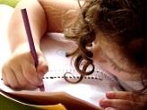  Literacy  Year 5 will be focusing on suspense writing in our fiction unit. Our model text will be “The Nightmare Man”. Later on, in the half term, Year 5 will turn their attention to non-fiction and the text be an explanation text. Our model text will be an explanation about why monsters are extinct.  Reading  In our whole class reading sessions, we will be carrying on with our class story “The Thief”. The children are really engrossed in the story and we are looking forward to finding out what happens next! The class will also look at a selection of non-fiction and poetry texts. | Maths  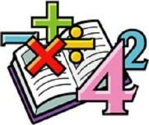  In maths, we will be continuing the great work done in year 4 on multiplication and division. We will be multiplying a 2-digit number by a 2-digit number and dividing a 4-digit number by a 1-digit number.  Later on, in the half term, we will be returning back to our fractions unit.  We will be continuing to learn and practice our times table skills, to make sure we are fluently recalling them quickly and accurately. We will be completing arithmetic tests every week to make sure we are continuing to practise key skills and embed new ones. |   Science  In science this half term we will be exploring animals including humans. We will be exploring how different plants can reproduce. In addition, we will be studying and understanding different life cycles of various animals and analysing similarities and differences between them. | Computing  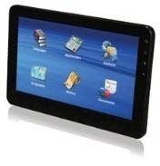  In computing, the children will make stop motion animations. The children will gain a knowledge of what animation is before planning and creating their own stop motion animation videos.
  Humanities  In Geography, the children will study all about rivers. We shall explore the various features of rivers. The children will utilise their geographic knowledge to locate and distinguish between several rivers around the world. | Our class books  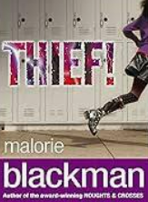 |  | 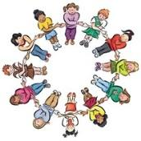  PSHE/RSE  This term in PSHE/RSE, we will be discussing matters relating to citizenship. Children will develop their understanding of democracy, laws, and individual rights. The pupils will also learn about different forms of government, the role of elected representatives, and how they can actively participate in their communities.
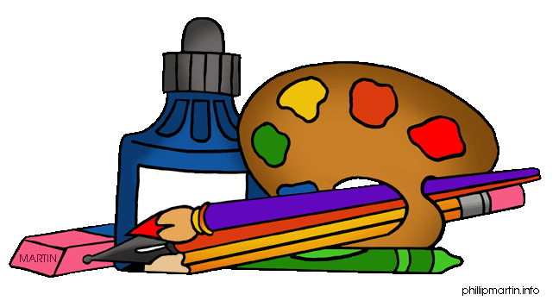  Design Technology:  This half-term, in DT, we will be designing pop-up books. The children will work from a design brief to develop a pop-up book for a specific audience. |   PE  In PE we will learn about gymnastics. The children will experiment with different rolls, bridges and ways of travelling before putting on a performance for their peers. We will continue with our weekly swimming sessions on a Monday morning. |   French  We will expand our French skills by learning different directions in French. We will also explore the French-speaking world and the various countries where the French language is spoken. |   RE  In RE, we will be looking at a key question.  Our key question this half term is:  Why is the Torah so important for Jewish people?

